

**PROGRAM**

**Training in U.S. Constitutional Criminal Procedure**

**Tbilisi 18th – 29th of March 2019**

*Organized by the European University of Tbilisi in partnership with the Center for International Legal Studies*

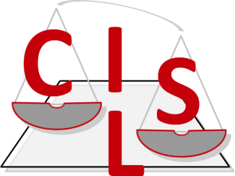.

# Morning

**Monday 18th of March**

*12h00 – 13 h00* **OPENING CEREMONY**

*13h00 – 14h00* **Introduction to Basic Criminal Procedures**

**Tuesday 19th of March**

# 

# Morning

*12h00 – 13h30* **Fourth Amendment**

# 

**Wednesday 20th of March**

# Morning

*12h00 – 13h30* **Fourth Amendment**

**Thursday 21th of March**

# Morning

*12h00 – 13h30* **Fifth Amendment : Self-Incrimination**

**Friday 22th of March**

# Morning

*12h00 – 13h30* **Fifth Amendment**

**Morning**

**Monday 25th of March**

*12h00 – 13h30* **Sixth Amendment**

**Tuesday 26th of March**

**Morning**

*****12h00 – 13h30* **Sixth Amendment**

**Wednesday 27th of March**

# Morning

*12h00 – 13h30* **Eighth Amendment**

**Thursday 28th of March**

# Morning

*12h00 – 13h30* **Due Process Clause**

**Friday 29th of March**

# Morning

*12h00 – 13h00* **Ethical dilemmas**

13h00 – 13h30 Coffee break

13h30 – 14h00 **Closing remarks**

*14h00 – 15h00* **Final Examination**

15h00 – 15h30 Coffee break

*15h30 – 16h00* **CLOSING CONFERENCE**